1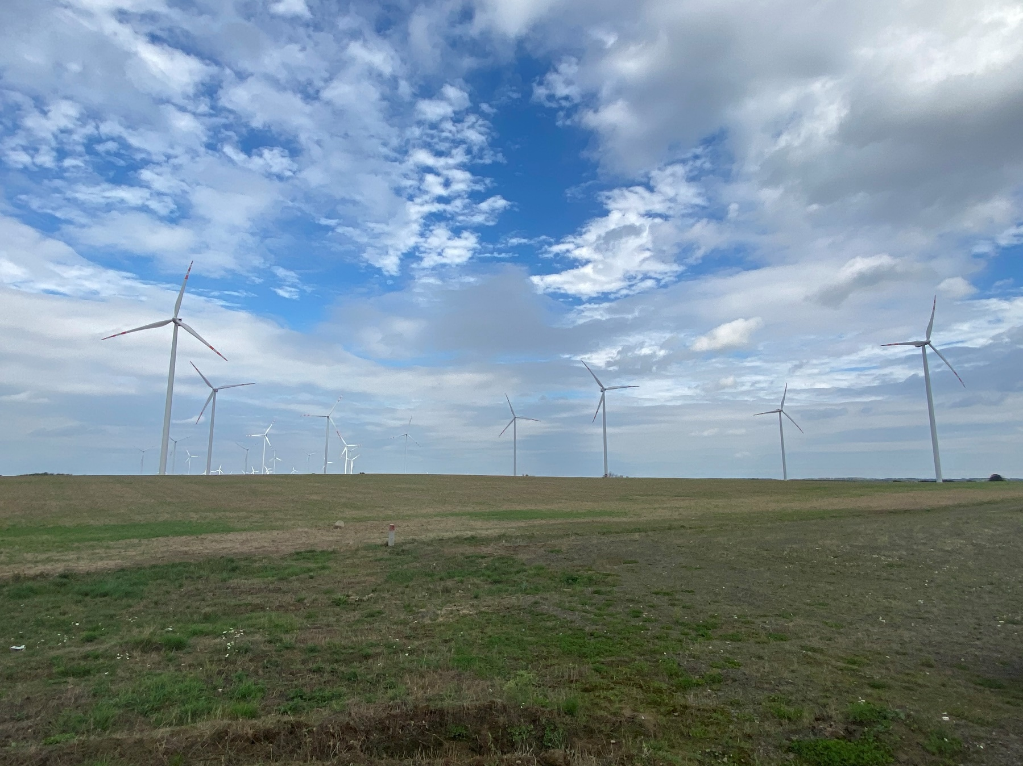

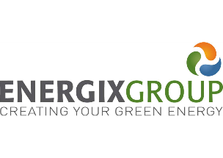 | Non-Technical Summary  Banie Phase 3 Wind Farm developed by Energix – Renewables Energies Ltd  02 February 2021

Document details
Document title | Non-Technical Summary
Document subtitle | Banie Phase 3 Wind Farm developed by Energix – Renewables Energies Ltd
Date | 02 February 2021
Client Name | Energix Renewable Energies Ltd.

Contents
Contents i
List of Figures i
Acronyms and Abbreviations i
1. INTRODUCTION 3
2. PROJECT DESCRIPTION 3
2.1.1 Project components and schedule 3
2.1.2 Land acquisition 6
3. SUMMARY OF IMPACTS AND MITIGATION MEASURES 6
3.1 Soil and groundwater 6
3.2 Air emissions and ambient air quality 7
3.3 Waste management 7
3.4 Biodiversity and nature conservation 7
3.4.1 Legally Protected Sites 7
3.4.2 Habitats and Flora/vegetation 8
3.4.3 Birds and bats 8
3.5 Community Health and Safety 8
3.5.1 Noise 8
3.5.2 Shadow flicker 8
3.5.3 Ice and blade throw risk 9
3.5.4 Public access 9
3.5.5 Project traffic 9
3.6 Socio-economic 10
3.7 Landscape and visual 10
3.8 Cultural heritage 10
4. EnvIronmental and Social Management 11
4.1 Stakeholder engagement 11

List of Figures
Figure 2-1 Banie 3 WEP layout 4
Figure 2-2 Vestas WTGs 5
Figure 2-3 Protected and designated areas within 10 km of Banie 3 wind farm 5
Figure 2-4 General lands overview in the area selected for Banie 3 wind farm 6

Acronyms and Abbreviations
Name | Description
BoP | Balance of Plants
EHS | Environmental, Health and Safety
EIA | Environmental Impact Assessment
E&S | Environmental and Social
ESAP | Environmental Social Action Plan
ESIA | Environmental and Social Impact Assessment
ESMS | Environmental and Social Management System
OHS | Occupational Health & Safety
MW | MegaWatt
PS | Performance Standard
SEP | Stakeholder Engagement Plan
WEP | Wind Electric Plant
WT/ WTG | Wind Turbine/ Wind Turbine Generator

INTRODUCTION
This Non-Technical Summary (NTS) provides an overview on the environmental and social impacts associated with the construction and operation of the Banie 3 Wind Farm (hereinafter referred to as “the Project”) and on the measures considered to keep these potential impacts at acceptable levels.
The Project is being developed by Energix Renewable Energies Ltd. (Energix Group, hereinafter referred to as “the Project Owner”), which is one of Israel’s largest renewable energy companies with a portfolio of more than 1GW of projects under development. The Group also runs the existing 106 MW Banie Windfarm (Banie 1 and 2), which is the second largest in Poland.
Energix Group intends to now develop the third part of the Banie Wind Farm, comprising 37 onshore turbines with a total capacity of 81.4 MW and associated project components. The Project is located in the area of Banie commune (Banie, Baniewice, Kunowo, Lubanowo, Piaseczno, Sosnowo, Swobnica and Tywica villages) and Widuchowa commune (Żelechowo village), in Gryfino County, West Pomeranian Voievodship in north-western Poland.
The Banie 3 Project is already approved by the Polish authorities: the an Environmental Impact Assessment (EIA) process was done in 2019 and the Project obtained the development consent and the associated permits for construction.
Energix Group is seeking to enter a financial agreement with financial institutions which have additional requirements besides the Polish procedures already completed. Therefore, the following additional studies and documents were commissioned so that the Project also meets the requirements of the EBRD, IFC, EP IV environmental and social standards:
- this NTS;
- a Stakeholder ngagement Plan (SEP)
- a Supplemental Study Report to Local EIA, and
- an Environmental and Social Action Plan (ESAP).
For Banie 3, Energix’s main constructor contractor, under the Company’s supervision, will develop a set of topic-specific Management Plans, accompanied by a Commitments Register, to document how Project-related impacts will be managed during construction. Furthermore, Energix will continue implementation of the commitments during operation, to assure the Project will not have negative impacts on environment and local communities.

PROJECT DESCRIPTION

Project components and schedule
The Project is planned outside settlement boundaries, on an arable land, within the territory of Banie and Widuchowa communes. The main Project components will include the 37 WTG, a project substation, the underground MV line and the internal access roads:
- 34 Vestas110 WTG located in Banie commune, with a 110-m rotor diameter and a hub height of 120 m; each WTG will have a capacity of 2.2 MW, which results in a total Project capacity of 74.8 MW;
- 3 Vestas110 WTG located in Widuchowa commune, with a 110-m rotor diameter and a hub height of 120 m; each WTG will have a capacity of 2.2 MW, which results in a total Project capacity of 6.6 MW.
- one 30/110 kV Project electrical substation covering an area of approximately 4700 m² located on the land plot no. 281/3, precinct Lubanowo, Banie commune;
- the 3 WTGs located in the Widuchowa commune will be connected via an underground MV line to BEW 36 WTG located in Baniewice.

Figure 2-1 below shows the Banie 3 WEP layout and Figure 2-2 presents the location of the Project in relation to natural protected and / or designated sites.
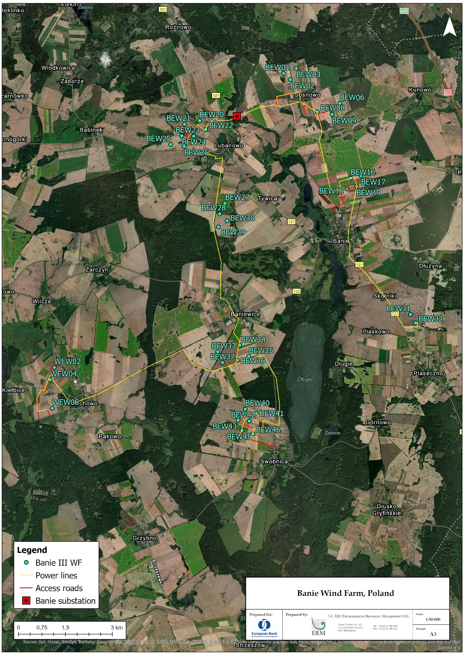
Figure 2-1 Banie 3 WEP layout
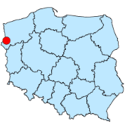

Figure 2-2 Vestas WTGs
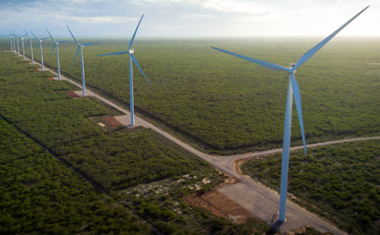
Source: www.vestas.com

Although the Project site is surrounded by Special Protection Areas (SPAs) as defined by the European Natura 2000 Birds Directive, all wind turbines are located outside of the borders of the protected areas / designated sites.
Figure 2-3 Protected and designated areas within 10 km of Banie 3 wind farm
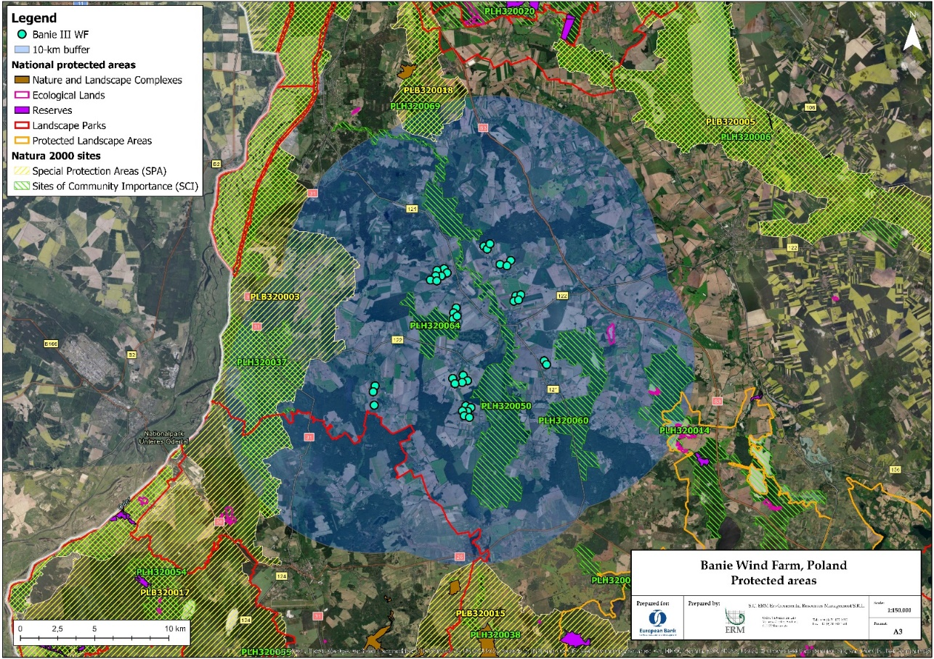

The indicative Project schedule assumed the construction activities would start Q1-2021 and would be completed by end of 2021. The final completion of the works is currently scheduled for spring 2022. The exact schedule for the works will depend on the selected construction company.

Land acquisition
The Project will not require physical displacement of people, all land required for the Project being located outside of the Banie and Widuchowa communes, on agricultural plots. Land for permanent project components has been acquired via voluntary land lease agreements with private owners or easement agreements with public authorities for roads and cable lines. The agreements were negotiated on a case-by-case basis, following individual negotiations.
Figure 2-4 General lands overview in the area selected for Banie 3 wind farm
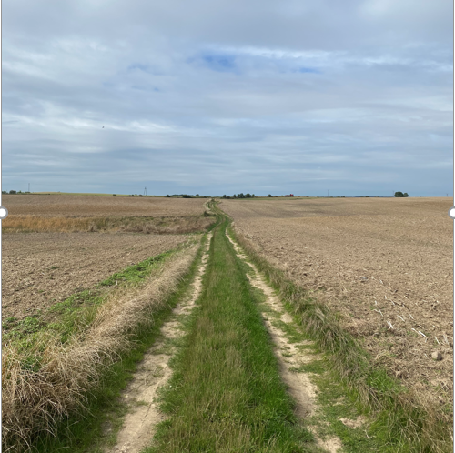

SUMMARY OF IMPACTS AND MITIGATION MEASURES

Soil and groundwater
Potential impacts on soil and groundwater during the Project construction could be associated with removal and handling of topsoil, soil compaction and potential spills of fuel, lubricants and paint. Potential impacts on soil and groundwater generated by future operations of Banie 3 WEP could potentially result from leakage of lubricants from the wind turbine nacelle and the transformer substation. However, this is unlikely due to the liquid retention systems integrated into the structure of the wind turbine nacelle and of the electrical substation.
Energix Group’s main construction contractor, under the Company’s supervision, will voluntarily develop a Resource Efficiency and Pollution Prevention and Control Management Plan for the Project to include measures that will be implemented on site to avoid potential contamination, for example:
- avoid storage of construction waste outside designated areas for temporary storage;
- implement preventive maintenance of construction vehicles and machinery;
- place machinery and equipment on metal trays to collect oil, condensate and diesel spills;
- avoid storage of construction waste outside designated areas for temporary storage;
- conduct refuelling outside the construction site.
Similarly, during construction, Energix’s main contractors, under the Company’s supervision, will develop and implement a Waste Management Plan to cover all waste streams generated by the Project activities and will make sure that the waste is temporarily stored and managed in line with national requirements and international best practices. The Waste Management Plans developed by the Company’s contractors will be approved by Enegix which will further monitor their implementation through internal audits.
With the above mitigation measures in place, impacts on soil and groundwater are not expected to be significant.

Air emissions and ambient air quality
During Project construction, air emissions sources will consist of dust generated from construction activities (e.g. land clearance and excavation, traffic on local roads) and combustion-related emissions from vehicles and construction equipment. These impacts will be mitigated by employing good construction practices, including using well-maintained construction equipment and employing dust abatement measures. Such measures will be included in the Resource Efficiency and Pollution Prevention and Control Plan to be developed and implemented for the Project by Energix’s main construction contractors, under the Company’s supervision.
No significant air quality impacts are associated with the Project operational phase. Operational traffic emission impacts will be associated with a limited number of vehicles accessing the site for maintenance or security purposes.

Waste management
All waste categories resulting from construction works related to the administrative area will be handled by specialized companies. The measures envisaged for mitigating impacts include: storage of building materials and waste in dedicated areas, monitoring the state of oil filters and vehicles to prevent leakages, maintenance of auto and construction equipment, refuelling equipment from a special tanker with the use of pallets.

Biodiversity and nature conservation

Legally Protected Sites

Although the Project site is surrounded by Special Protection Areas (SPAs) as defined by the European Natura 2000 Birds Directive, all wind turbines are located outside of the borders of the protected areas / designated sites. The nearest SPAs are Dolina Dolnej Odry (PLB320003), birds protection area, located approximately 4.75km west of the Project site, and Jeziora Wełtyńskie (PLB320018), located approximately 6.7km north-northeast.
The Project area was identified as important for breeding White-tailed eagle Haliaeetus albicilla, which is a qualifying species for the neighboring SPAs. Since the Project does nor overlap with natural protected areas, the Polish authorities did not require an Appropriate Assessment (AA) Study. Energix Group will voluntarily undertake additional supplementary surveys and assessments to mitigate potential effects on the Natura 2000 sites integrity.

Habitats and Flora/vegetation
The Project components are mostly located on agricultural land associated; therefore, only modified habitat (and not “natural habitat”) may be impacted by the Project. Therefore, no significant impact is expected on vegetation and habitats for animals.

Birds and bats
Birds and bats are particularly sensitive to windfarm operations. The assessment of potential impacts on biodiversity receptors was based on three campaigns of field studies in 2009, 2013 and 2019. In addition the EIA was informed by bird and bat monitoring reports that cover the Banie 3 area. The baseline identified six species of bats and 105 species of birds, eleven of which are listed under Annex I of Birds Directive (meaning the threatened bird species in danger of extinction; vulnerable to specific changes in their habitat; considered rare because of small populations or restricted local distribution; requiring particular attention for reasons of the specific nature of habitat).
The Company will appoint an Independent Ornithological and Chiropterologist (birds and bats) expert (IOCE) to undertake monitoring of the Project during commissioning then of all the three Banie Projects subsequently during operation.
As common practice for windfarm operations, the monitoring includes a check of carcasses of dead birds and bats around the turbines to determine the extent of impacts, and if further protection needed.
In addition to the surveys undertaken during the EIA process, Energix Group will voluntarily undertake additional supplementary surveys for birds and bats, using quantifiable methods such as VP (Vantage Point) surveys and CRM (Collision Risk Modelling) and will implement additional measures to protect biodiversity. The above mentioned surveys and assessments supplemented by further desk study and consultation, will assist with identifying whether automated approaches such as DTbird would be suitable, and if so, how best to configure them. Such studies will also assist in refining and understanding peak risk periods, when shut down procedures may be most effective.
Based on the results and if necessary, Energix and its consultants will develop a shut down on demand procedure to be used by the IOCE to shut down individual turbines if needed due to risk of collision with the endangered birds (e.g. white tailed eagle).
I addition, a bat mitigation procedure will be established for the Project, to include triggers for change based on the number of bats per turbine killed assessed against European averages for operational turbines and population levels. Results from the carcass monitoring in relation to time of year and location of casualties will be used to optimise any curtailment regime.

Community Health and Safety

Noise
For this project, Energix has selected turbines type Vestas V110 which are less noisy than the other types of similar turbines.
In order to minimize negative impact during construction phase of the Project, the following rules will be implemented:
- the construction timeline will be organized in a way to reduce the number of construction days to the minimum;
- all ground works will be conducted between 6 am and 10 pm only;
- all equipment and machines will be of a good technical condition;
- temporary areas created for the construction works purposes as well as transportation routes, will be placed as far away as possible from the nearest residential areas;
- engines of trucks and machinery will be turned off during work breaks.
The EIA performed in 2019 and the Supplemental study to local EIA (ERM, 2020) include noise analysis for new investment alternatives. The noise modelling results show that, during operation, it is expected that the Project to be in compliance with the limits established by Polish Law and IFC / international standards.
Confirmatory noise monitoring during the operational phase will be conducted in line with the Polish regulations and international standards and, if exceedances are identified, relevant mitigation measures will be defined and put in place.
The implementation of the measures will be done in consultation with the communities as part of the stakeholder engagement process described under section 4.

Shadow flicker
Shadow flicker refers to the on-off “strobe effect” that may be experienced by a viewer when the sun is setting behind a windturbine, and the rotor blades pass in front of the sun causing rapid change of light and shadow.
Areas that are particularly sensitive to shadow flicker impacts are residential houses in the vicinity of the wind turbines. A shadow flicker is observed when the windows in a house are facing the wind turbine, and the position of the sun on the horizon results in a shadow of the turbine blades to be cast on the window.
In general, the maximum impact distance from the wind turbines at which the impacts of shadow flicker will be observed is 10 times the rotor diameter distance. The turbines planned for this Project have rotor diameters of 110m, meaning that shadow flicker may extend about 1100 m.
The Project Owner will voluntary undertake additional screening to assess shadow flicker impacts, starting with the identification of all receptors within the maximum potential impact distance and then assessing the significance of impacts upon each receptor. An External Grievance mechanism will be put in place to allowing the residents to raise complains or flag any associated issues during the operation stage.

Ice and blade throw risk
Wind farms operating in cold climates may suffer from icing in certain weather conditions and ice throwing from the wind turbines may affect public safety. Also, in case of damage to the rotor blades, it is possible that some parts of the blade may break off and be thrown from the turning rotor.
The calculations conducted for the turbines of the Banie 3 Project indicate that ice throw may extend to a distance of approximately 360 m and blade throw to 480 m.
There are no houses within these ranges, but some farm fields and roadways. In order to mitigate any risks to community health and safety, warning signs will be posted at the entrance to the Windfarm’s area and periodical checks of each WTG location will be made with focus on safety and warning signs condition is performed. Additionally, the local public and authorities will be informed so that the Company can respond quickly to any issues related to ice and blade throw risk.
With the aforementioned mitigation in place, no significant impacts from ice or blade throw are expected.

Public access
Potential impacts to community health and safety may arise as a result of:
- transportation of people, goods and Project components during construction;
- noise generated by the wind turbines;
- shadow flicker and electromagnetic interference.
A Community Health and Safety Plan (CHSP) will be developed by Energix’s contractors to define health and safety measures for the protection of the local communities. This Plan will also include measures to addresses community exposure to diseases, with particular focus on COVID-19. Energix will approve the plan and further monitor its implementation through internal audits to its contractors and by reviewing the external grievance log which records the complains or recommendations raised by the communities or general public.

Project traffic
The potential impacts of increased heavy and oversized transportation may include:
- increased noise, vibrations and particulate matter;
- increased traffic on the local roads (delivery of construction materials, wind farm components);
- damages to road’s surface and possibly also building structures; and
- temporary roads access.
During the construction phase, Energix’s contractors will develop and implement a Traffic Management Plan (TMP), which will describe truck routes and planned schedule when heavy and oversized transportation can be expected. Energix will approve the plan and further monitor its implementation.
Appropriate public communication to allow timely notice of affected residents before major construction operations or traffic movements on public roads will be implemented before commencement and during construction phase of the Banie 3 windfarm.
Currently, the area of the planned Banie 3 windfarm is used for arable farming. Measures to allow safe access to farming areas will be identified and implemented upon consulting local authorities and residents. These will be reflected in the Traffic Management Plan.
If the abovementioned mitigation measures will be implemented, no significant transportation impacts would be anticipated to occur.

Socio-economic
The following types of socioeconomic impacts are likely to arise as a result of the Project construction:
- positive impacts:
  - direct employment opportunities with the Project; the exact number of required construction workforce is still to be defined at this stage but the Project could involve up to 50 workers;
  - direct economic impacts as a results of Project purchase of goods and services such as construction materials for civil works, construction equipment and machinery, catering, transportation; the Project owner will seek to maximize local procurement of goods and services for the Project;
  - induced economic effects of spending by construction workers;
  - increase of the commune income through payment of taxes by the Project owner;
  - increase of household income of land owners leasing their land for each WTG. The land for the Project was secured based on land lease agreements signed with the land owners by the Project owner;
  - improvement of local communication routes (4 km);
  - potential positive impacts on community cohesion arising from the influx of construction workers;
- potential adverse impacts:
  - permanent loss of arable land;
  - potential increased pressure on local infrastructure and utilities as a result of transporting goods and services, constructing new roads and rehabilitating existing ones, wiring the wind farm.
The operational stage will also feature both direct employment opportunities with the Project and indirect opportunities, as the Project will subcontract maintenance and security services.

Landscape and visual
In order to mitigate any potential landscape and visual impacts, the following measures will be implemented:
- smooth cylindrical towers will be used, as this type of tower has a simpler configuration, less complex surface characteristics and a lower reflection/shadow casting potential;
- non-reflective paints and coatings will be used to reduce glare;
- only underground power cables will be used at the site to minimize distortion of the surface.

Cultural heritage
The existing EIA provides a list of 30 protected heritage sites in the vicinity of the proposed wind farms. In most cases these are communal monuments: churches, graveyards and parks. They are very largely distributed within the historic villages and towns of the area: Banie 1, Sosnowo, Lubanowo, Baniewice, Piaseczno, Gornowo and Swobnica. The region of the Szczecin Lowlands – well-watered and fertile - is rich in archaeological heritage including, for example, large numbers of prehistoric monumental burial sites. There has been very extensive development in Western Pomerania in recent decades, including the construction of the S3 motorway in the 2000’s which involved large-scale pre-construction archaeological works. These identified large numbers of buried archaeological sites of all periods – prehistoric, Roman and medieval – throughout the corridor which runs 3.5+km to the east of the proposed wind turbines.
However, no historical and cultural heritage was discovered within the Project area. Nevertheless, in accordance with good international practice, the Project Owner will voluntarily develop and implement a so-called “chance finds procedure” that prescribes how any cultural heritage that may be identified during the construction works will be managed and define relevant roles and responsibilities for the process.

EnvIronmental and Social Management
The local EIA prepared for the Project identified the potential environmental impacts associated with the Project and defined mitigation measures to be implemented in order to maintain these impacts within acceptable limits. Additional measures to comply with international (EBRD, IFC, EP IV) standards were added for the project. These measures are included in the Environmental and Social Action Plan (ESAP), which represents a roadmap for implementation of key environmental and social actions required for the Project.
Energix Group will implement an Environmental and Social Management System with policies and procedures, as well as, through its contractors, management plans to manage environmental and social aspects. Energix will also develop and implement a Stakeholder Engagement Plan (SEP) that will:
- define the relevant Project stakeholders, planned engagement activities, resources from the Project Owner to deal with stakeholder engagement, a community grievance mechanism and a management process along with monitoring and evaluation. The Project SEP will aim to lay the foundation for an effective, bilateral communication between the Project and its stakeholders, and to build reliable relationships between the Project and local communities. Regular stakeholder engagement will also enable the Project Owner to gain a better understanding of the ways in which communities prefer for receive information about the Project. The Project SEP will be made available to the public on the Project Owner’s website, and as hard copy to local authorities and communities. It will be periodically updated as needed, to reflect engagement undertaken, stakeholder feedback and potential changes in the Project.
- feature a formal grievance management procedure for the Project. This mechanism will be disseminated to the affected communities so that people understand how to proceed in case they have questions or complaints in relation to the Project.
- furthermore, in order to build community members’ trust in the Project and its contribution to local development, the Project Owner will elaborate and implement an annual Community Investment Plan, engaging appropriately all relevant parties and, in particular, the neighbouring households impacted during construction and/ or operation of the Project.

Stakeholder engagement
Energix Polska team maintains engagement with the communes’ administrations, land owners and the community at large. The overall responsibility for external engagement lies with the Construction Manager, with the support from the Project Manager who will be present on site on a daily basis. The Project Manager will be close to the site, making sure that everything is running smoothly and can escalate matters to Construction Manager as required for timely and effective resolution.
Prior to 2018, the information and consultation activities conducted for the Project were largely limited to complying with the permitting requirements of Polish legislation, according to existing documentation. The public could participate in the EIA proceedings from April 10 to May 9, 2019, and from May 29, 2019 to June 27, 2019, with the case files being available for review at the seat of Banie commune. No comments from the public were received during the proceedings, as reported in the Environmental Decisions.
During the process of changing the building permit in 2019, the Company has been in contact with the local stakeholders, focusing on commune and county authorities and land owners, regarding many aspects: introduction, project updates, EIA (2019) process, update of the building permit. This was achieved via daily contact with the authorities and monthly meetings with both authorities and land owners, attended by Energix Construction Manager, Country Manager, Operation Manager, Israel HQ relevant functions, WKB consultants, as per the case.
During construction, the contractor will be responsible for engagement with the local community, under the supervision of Energy Polska team. During operation, it will be Energix Polska who will conduct the turbine condition monitoring and will prepare the required operation policies. These agreements will include the requirement that if anything material occurs at any moment, the owners’ engineer and the investor are to be informed.
Prior and during to construction, Energix plans to organize a kick-off meeting with the authorities and with the land owners where they are going to present how the construction works will look like, what type of equipment is coming to the site, when they should expect it, to agree with the farmers when should the works start so to minimise damages in crops and any other issues raised by the local community. Additionally, the company will distribute information including expected locations of the turbines, expected routes for transport of the construction equipment and turbines, timeline for construction, details about the contractors and contact details for contractor and investor, alongside emergency contact details. For operation stage, a similar leaflet will be created and distributed locally.
Acting as a corporate citizen, the company proactively donated sanitary devices for the schools and public institutions in Banie commune, in support of local safety measures required by the Covid-19 pandemic. Additionally, the company answered a support request for a sports community event for children in September 2020.

